NEWSLETTER
TEMPLATES
Promotional Copy to Help You
Promote Tutor.com to Your Patrons

Questions? Comments?
clientsupport@tutor.com
2020_LIB_Newsletter_Templates

Promotional Topics Included in This Packet:

- K-12 Newsletter Article
- SAT® / ACT® (College Prep) Newsletter Article
- Adult Learner Newsletter Article
- Career Help Newsletter Article
- Where to Find More Promo Materials

K-12 STUDENT ARTICLE
for LIBRARY NEWSLETTER
CONNECT. LEARN. GO!
Did you know? Tutor.com can help you get your homework done, write your paper, or study for your test so that you can get back to your life. If you’re getting frustrated, Tutor.com can help you get unstuck. Create a FREE account or log in through [LIBRARY NAME] to get the help you need, online and on-demand. Tutors are available [INSERT your library program’s tutoring days and hours].
“Now it doesn’t take me 3 hours to finish my chemistry homework. I love Tutor.com!”
—10th Grade Student
Students and parents can get help with any kind of academic question in math, science, English, social studies and writing. Expert tutors work with students in kindergarten through 12th grade and can even help with AP®-level and intro-level college coursework.
Connecting with a tutor is easy. You just need your library card and any Internet-connected device. Head to [INSERT your library’s unique program URL/access instructions]. Connect. Learn. Go!

SAT®/ACT® ARTICLE
for LIBRARY NEWSLETTER

Hey High School Juniors and Seniors!
Did you know? Tutor.com can help you on your path to college. Thinking about the SAT® or ACT®? Your score is a key component of your college admissions process. Be sure to check out Tutor.com’s SAT/ACT Essentials service, free with [YOUR LIBRARY NAME]’s Tutor.com service. SAT/ACT Essentials, powered by the world leader in test prep, The Princeton Review®, will give you the edge you need to reach your target score. With this free service you’ll be able to:
- Complete a full-length practice test and see your score
- See the areas in which you need to improve
- Watch videos to learn important test-taking strategies
- Take practice drills to help raise your scores!
We know that preparing for college can be overwhelming. Fortunately, SAT/ACT Essentials is available 24/7—so can easily fit study time into your busy schedule.

Just remember: Getting into your dream school takes more than great test scores. Tutor.com can also help you boost your GPA with free academic tutoring from expert tutors. Get on-demand homework help, assistance in writing a strong college application essay, and more! You just need your library card to get started! Visit [INSERT your library’s unique program URL/access instructions].

[Insert current year’s SAT/ACT test dates here]

ADULT-FOCUSED ARTICLE
for LIBRARY NEWSLETTER

The Tutor.com Adult Education Center
Free, on-demand, anonymous tutoring available online through [INSERT Library Name]
Are you returning to school, working towards your GED, or refreshing your skills for work? Get anonymous, private, online tutoring for any kind of academic question in math, science, English, social studies, and writing anywhere you have an internet connection with Tutor.com—FREE through your library!
Expert tutors are available to you [INSERT your library program’s tutoring days and hours]. Visit [INSERT your library’s unique program URL/access instructions] from any Internet-connected device. Click on the link for Tutor.com and enter your library card to get started. Tutor.com’s expert tutors can help you on anything from learning how to add fractions to understanding your college-level statistics class.
You can choose to connect with a tutor right away or use one of the other great features of the service, including practice quizzes to help study for an exam, online resources from the Tutor.com SkillsCenter Resource Library, and the Drop-Off Writing Review service where expert writing tutors review and give you feedback on your writing assignments before you have to turn them in!
If you’d like a demonstration of how to use the service, please visit the library or ask your tutor for a tour of the classroom at the start of your session. Don’t be afraid to get the (FREE!) help you need. Improve the quality of your education—and your life—by logging in today! [INSERT your library’s unique program URL and access instructions]

CAREER HELP ARTICLE
for LIBRARY NEWSLETTER

The Tutor.com Career Center
Help for Job Seekers Is Just a Click Away!
Out of work? Looking for a career change? Need to dust off your resume? You don’t have to face it alone. [INSERT LIBRARY NAME] can help you reach your goals with the Tutor.com Career Center—absolutely FREE to you. Get anonymous, private, online career coaching and job search assistance. All you need is your library card and an Internet connection!
What are my options?
- Tutor.com Career Coaching: Work one-to-one with professional career coaches in a private, supportive environment for help with job searching, resume writing, interview preparation, and more.
- Tutor.com Drop-Off Resume Reviews: Drop off your cover letter or resume any time, 24/7 for an overnight review. Career tutors will write up a summary of feedback and leave comments on your document. You’ll receive the tutor’s review in your own secure online drop box.
- Tutor.com SkillsCenter™ Resource Library: Access helpful resources for your job search, including resume and cover letter templates and samples.
Tutors are available [INSERT your library program’s tutoring days and hours]. Need help at a different time? No problem! The Drop-Off Review Service & SkillsCenter Resource Library provides 24/7 access to the career tutors and thousands of job search resources such as resume templates and interview tips.
Getting help is easy. Just go to [INSERT your library’s unique program URL and access instructions]. To learn more about the program, visit your library ask your Tutor.com tutor for a tour of the online classroom during your first session.
Don’t be afraid to get the (FREE!) help you need. Log in today!

Looking for More Promotional Materials?

Be sure to check out your Tutor.com Client Resource Center at tutor.com/clientcarelib for more resources to help build awareness of the program, including digital marketing pieces for use in emails, newsletters, on websites, social media, and more!

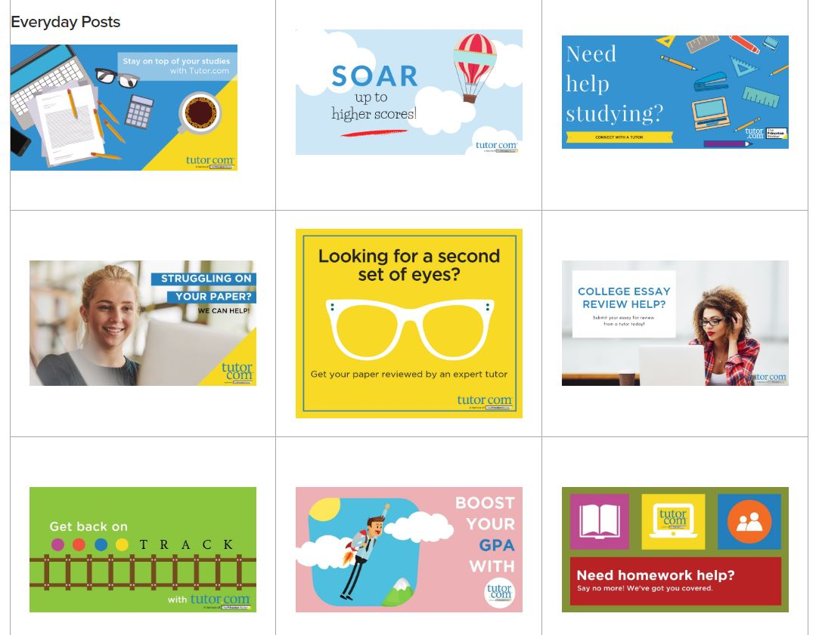

Questions? Comments?
clientsupport@tutor.com

