PROMOTIONAL COPY
Email and Social Media Templates
to Promote Tutor.com™ to Your Students

Promotional Topics Included in This Packet:

- New Tutoring Service Announcement
- Back to School Reminder
- Mid-Term & Final Exam Reminders
- Subject-Specific Announcements & Reminders
- Course-Specific Announcements & Reminders
- Where to Find More Promo Materials
Promotional Copy:
New Tutoring Service

Email Template: New Tutoring Service
Dear Students,
We are very excited to introduce our new 24/7 online tutoring service from Tutor.com, available to [Institution or school name here] students beginning [DATE].
Tutor.com™ connects you with expert online tutors who can help you with:
[Customize subjects below with what is specifically available to your program]—
- Math – Algebra, Algebra II, Basic Math, Calculus, Geometry, Statistics, Trigonometry
- Science – Basic, Biology, Chemistry, Physics, Earth Science
- Business – Accounting, Finance, Economics
- English, Writing and History – Including real-time writing help
You’ll also have access to educational tools and study resources such as:
• Study tools and lessons
• Drop-Off Writing Review
• Diagnostic quizzes
• Instructional videos
This FREE tutoring service can be accessed from any Internet-ready device so you can have access to a tutor when and where you need one.
To get connected to a live tutor, [insert your institution’s access/registration instructions here].
If you have questions or need assistance, please contact: studentsupport@tutor.com.

Promotional Copy:
Back to School

Email Template: Back to School

Dear Students,

Welcome back to [Institution name here]! This year, remember to take advantage of FREE online tutoring from Tutor.com™, provided by [school/department name]. Expert tutors are available to you online, 24/7, to help you with assignments, concepts, and exam preparation. This service covers a wide range of subjects, including [list subjects offered in your program here].
Tutor.com™ makes it easy to sign up and get assistance immediately. To get connected to a live tutor, [insert your institution’s access/registration instructions here].
If you have questions or need assistance, please contact: studentsupport@tutor.com.

Promotional Copy:
Mid-Terms and Final Exams

Email Template: Mid-term Exams
It’s that time of year again: Mid-term exams are right around the corner! Remember that as a student at [insert institution name], you are eligible for free online tutoring from Tutor.com™, provided by [school/department name]. Expert tutors are on hand 24/7 to help you with questions, concepts and sample problems so that you are ready to ace your exams!

Getting started is quick and easy. To get started, simply [insert your institution’s access/registration instructions here]. If you have questions or need assistance, please contact: studentsupport@tutor.com.
Email Template: Final Exams/End of Semester
Stressing out over final exams? As a student at [insert institution name], you are eligible for free online tutoring from Tutor.com™, provided by [school/department name]. Expert tutors are on hand 24/7 to help you with questions, concepts and sample problems so that you are ready to ace your exams!
Getting started is quick and easy. To get started, simply [insert your institution’s access/registration instructions here]. If you have questions or need assistance, please contact studentsupport@tutor.com.

Sample Facebook Post: Mid-terms/Final Exams
Don’t let tests stress you out! Get the extra help you need with FREE online tutoring from Tutor.com™—on demand, 24/7. To get connected to your own live session, [insert your institution’s access/registration instructions here].

We hope you take advantage of this great study tool!

Sample Tweets: Mid-Terms/Final Exams
- Tests getting you stressed? Get FREE online help, 24/7, to make sure you’re prepared! [link]
- Time crunch to finish that assignment? Let our FREE 24/7 online tutoring get you to the finish line! [link]
- Need study help? Look no further! FREE one-on-one, 24/7 online tutoring is here! [link]
- Weighed down by your assignments? Lighten the load with our FREE 24/7 online tutoring! [link]
- Take your assignments to the next level with FREE 24/7 online tutoring! Connect live today: [link]

Promotional Copy:
Subject-Specific Announcements and Reminders
Need help with math?
Don’t let this term’s math course be a stumbling block on your path to academic success. We provide online tutoring to support your efforts in your coursework. Tutors can help you work through problems, prepare for quizzes and exams and provide you with valuable study resources.
Math tutors are available on demand, 24/7. Simply go to [insert your institution’s access/registration instructions here]. We hope you find this resource helpful to your academic success!
If you have questions or need assistance, please contact: studentsupport@tutor.com.

Need help with writing?
Did you know we offer real-time writing assistance to help support your success? You can connect with writing tutors online 24/7 to prepare an outline, develop your thesis statement, proofread for grammar, and check on your citations.
Writing tutors are available on demand. Simply go to [insert your institution’s access/registration instructions here]. We hope you find this resource helpful to your academic success!
If you have questions or need assistance, please contact: studentsupport@tutor.com.

Need help with Accounting?
This is a reminder to you that as a student at [insert institution name here], you have access to FREE online tutoring to help you with your accounting course(s) this term. Tutors can help you prepare for exams on key accounting topics such as financial reporting, capital investment decision-making, and tax accounting.
Accounting tutors are available on demand, 24/7. Simply go to [insert your institution’s access/registration instructions here]. We hope you find this resource helpful to your academic success!
If you have questions or need assistance, please contact: studentsupport@tutor.com.

Promotional Copy:
Course-Specific Announcements and Reminders
Below are sample course announcement postings for general reminders as well as required assignments. Faculty can customize the copy with information geared towards their students, then email or post it on their course announcements page.
Email Template: General
Dear Students,
I would like to encourage you to take advantage of our FREE 24/7 online tutoring service. You can connect with a live tutor at any time for one-on-one help with [insert course topics].
For more information and to get started, [insert your institution’s access/registration instructions here].
If you have questions or need assistance, please contact: studentsupport@tutor.com.
Email Template: Assignment-Specific
Dear Students,
Do you need help with [assignment name]? Remember that as a [insert institution name here] student, you are eligible for FREE 24/7 online tutoring from Tutor.com™. Through this service, you can connect to an expert tutor for help with [assignment name].
Tutor.com™ makes it easy to sign up and get help quickly. For more information and to get started, [insert your institution’s access/registration instructions here].
If you have questions or need assistance, please contact: studentsupport@tutor.com.
Email Template: Required Writing Assignment
Dear Students,
This is a reminder that you are required to complete an online tutoring session and submit your session transcript as part of your [assignment name]. Live tutors are available 24/7 for one-on-one help at your convenience – even at 2:00 a.m.!
To get started, go to [insert your institution’s access/registration instructions here] to register for an account. Once you’re logged in, select “Writing Center” and fill out the prompts to let the tutor know what you would like to focus on in your paper. Next, upload your paper into the online classroom and collaborate with your tutor as you review your paper together.
NOTE: BE SURE TO REMOVE ANY PERSONAL INFORMATION (including name) before uploading
At the end of your session, please print or email your session transcript. To save the file to your computer, you can access the transcript on the Previous Sessions section of your account page.
If you have questions or need assistance, please contact: studentsupport@tutor.com.
Email Template: Required Discussion Assignment
Dear Students,
This is a reminder that you are required to complete an online tutoring session and submit your session transcript as part of your [Discussion Assignment]. Live tutors are available 24/7 for your convenience.
To get started, go to [insert your institution’s access/registration instructions here] to register for an account. Once in the program, select your subject. Fill out the prompts to let the tutor know what problem or concept you would like to work on together. Once you are connected to the online classroom, you will be able to text chat with your tutor and work on an interactive whiteboard together.
At the end of the session, you can print or email your session transcript. To save the file to your computer, you can access the transcript on the Previous Sessions section of your account page.
If you have questions or need assistance, please contact: studentsupport@tutor.com.

Looking for More Promotional Materials?

Be sure to check out your Tutor.com Client Resource Center at www.tutor.com/prc/higher-ed for more resources to help build awareness of the program, including digital marketing pieces for websites, social media, and more.

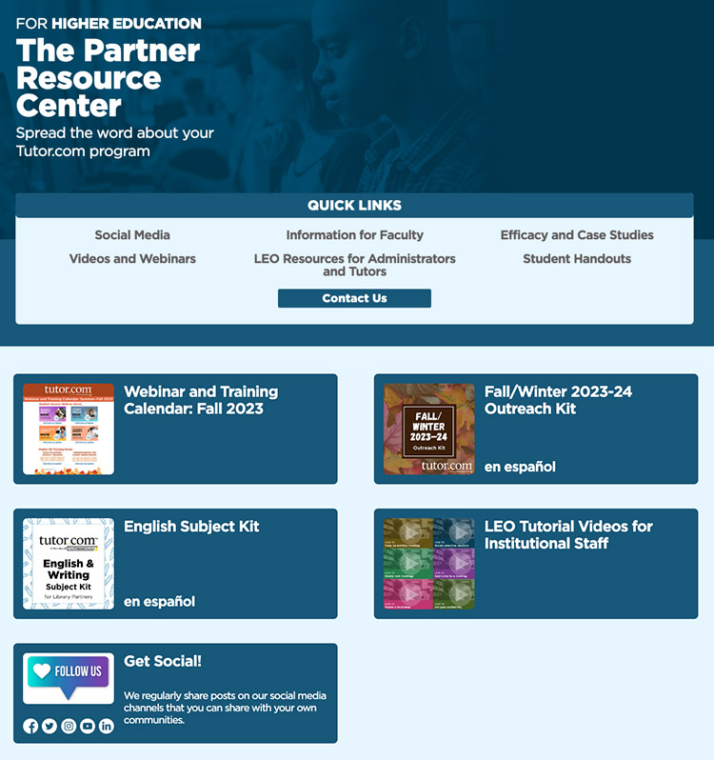

Questions? Comments?
clientsupport@tutor.com

