PROMOTIONAL
MESSAGING
Email and Social Media Templates
to Promote Tutor.com™ to
Employees & Their Families

Topics included in this packet:

- COVID-19 / e-Learning Messaging
- New Tutoring Service Announcement
- Back to School Reminder
- Mid-Term & Final Exam Reminders
- Subject-Specific Announcements & Reminders
- Class-Specific Announcements & Reminders
- Where to Find More Promo Materials

Relevant COVID-19 Crisis Copy:
Tutoring Service Available 24/7
Parent Email Template: Tutoring Service Available at Home!
Dear Student,
We recognize that this is an unprecedented and difficult time across the country, and that it is no doubt impacting all of you, particularly students. We want to remind you that you have resources available to support you during this uncertain time, and that learning does not have to stop just because school is out of session or has moved entirely online.
You can use tutor.com to get 1-on-1 support in a secure online classroom in over 60 subjects. Just visit WEBSITE and log in to get academic support anytime, 24/7, with a live expert tutor.
If you have any questions, please visit tutor.com/contact-us or contact your COMPANY.

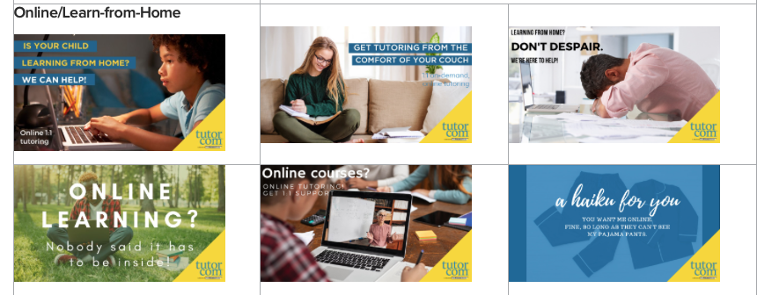

Promotional Copy:
New Tutoring Service

Email Template: New Tutoring Service
Dear EMPLOYEE,
We are very excited to introduce our new 24/7 online tutoring service from Tutor.com, available to COMPANY students beginning [DATE].
Tutor.com™ connects you with expert online tutors who can help you with subjects like:
- Math – Calculus, Discrete Math, Trigonometry, Statistics, and more
- Science – Astronomy, Geology, Biology, Chemistry, Organic Chemistry, and more
- Business – Accounting, Macroeconomics, Management, and more
- English and Writing – Literature, live writing help, Grammar, and more

You’ll also have access to educational tools and study resources such as:
• Student Success: Life Skills and Study Skills
• Drop-Off Writing Review
• Diagnostic quizzes
This FREE tutoring service can be accessed from any Internet-ready device so you can have access to a tutor when and where you need one.
To get connected to a live tutor, go to WEBSITE.
If you have any questions, please visit tutor.com/contact-us or contact your TEAM.

Promotional Copy:
Back to School

Email Template: Back to School

Dear Students,

Welcome back to school! This year, remember to take advantage of FREE online tutoring from Tutor.com™, provided by COMPANY. Expert tutors are available to you online, 24/7, to help you with assignments, concepts, and exam preparation. This service covers a wide range of subjects, including calculus, organic chemistry, nursing subjects, writing, and more.
Tutor.com™ makes it easy to sign up and get assistance immediately. To get connected to a live tutor, just visit WEBSITE.
If you have any questions, please visit tutor.com/contact-us or contact your TEAM.

Promotional Copy:
Mid-Terms and Final Exams

Email Template: Mid-term Exams

It’s that time of year again: Mid-term exams are right around the corner! Remember that as an employee of COMPANY, you are eligible for free online tutoring from Tutor.com™, provided by. Expert tutors are on hand 24/7 to help you with questions, concepts and sample problems so that you are ready to ace your exams!

Getting started is quick and easy. To get started, simply visit WEBSITE. If you have questions or need assistance, please contact: studentsupport@tutor.com.
Email Template: Final Exams/End of Semester
Stressing out over final exams? As a part of COMPANY, you are eligible for free online tutoring from Tutor.com™. Expert tutors are on hand 24/7 to help you with questions, concepts and sample problems so that you are ready to ace your exams!

Getting started is quick and easy. To get started, simply visit WEBSITE. If you have questions or need assistance, please contact: studentsupport@tutor.com.

Have a great end of semester!

Sample Facebook Post: Mid-terms/Final Exams
Don’t let tests stress you out! Get the extra help you need with FREE online tutoring from Tutor.com™—on demand, 24/7.

To get connected to your own live session, just visit WEBSITE

We hope you take advantage of this great study tool!

Sample Tweets: Mid-Terms/Final Exams
Tweet Example 1:
Tests getting you stressed? Get FREE online help, 24/7, to make sure you’re prepared! WEBSITE

Tweet Example 2:
Time crunch to finish that assignment? Let our FREE 24/7 online tutoring get you to the finish line! WEBSITE

Tweet Example 3:
Need study help? Look no further: FREE one-on-one, 24/7 online tutoring is here! WEBSITE

Tweet Example 4:
Weighed down with all your assignments? Lighten the load with our FREE 24/7 online tutoring! WEBSITE

Tweet Example 5:
Take your assignments to the next level with FREE 24/7 online tutoring! Connect with a live tutor: WEBSITE
Promotional Copy:
Subject-Specific Announcements and Reminders
Need help with calculus?
This is a reminder to you that as an employee of COMPANY, you have access to FREE online tutoring to help you with your calculus class this year. Tutors can help you prepare for exams on key topics and concepts and help you get prepared for whatever your professor throws at you next!
Calculus tutors are available on demand, 24/7. Simply go to WEBSITE. We hope you find this resource helpful to your academic success!
If you have any questions, please visit tutor.com/contact-us or contact your TEAM.

Need help with science?
Don’t let this year’s science class be a stumbling block on your path to academic success. We provide online tutoring to support your efforts in your coursework. Tutors can help you work through concepts, prepare for quizzes and exams, and provide you with valuable study resources.
Science tutors are available on demand, 24/7. Simply go to WEBSITE. We hope you find this resource helpful to your academic success!
If you have any questions, please visit tutor.com/contact-us or contact TEAM.

Need help with writing?
Did you know we offer real-time writing assistance to help support your success? You can connect with writing tutors online 24/7 to prepare an outline, develop your thesis statement, proofread for grammar, and check on your citations. Don’t have time for a live session? You can also drop off an assignment to get tutor feedback within 12 hours.
Writing tutors are available on demand. Simply go to WEBSITE. We hope you find this resource helpful to your academic success!
If you have any questions, please visit tutor.com/contact-us or contact your TEAM.

Promotional Copy:
Class-Specific Announcements and Reminders
Below are sample class announcement postings for general reminders as well as required assignments. Your team can customize the copy with information geared towards their students, then email or post it for students.

Email Template: General
Dear __________,
I would like to encourage you to take advantage of our FREE 24/7 online tutoring service. You can connect with a live tutor at any time for one-on-one help with math, science, English, business, or nursing subjects, plus many more!
For more information and to get started, go to WEBSITE.
If you have any questions, please visit tutor.com/contact-us or contact your TEAM.

Email/Announcement Template: Assignment-Specific
Dear __________,
Do you need help with [assignment name]? Remember that as an employee of COMPANY, you are eligible for FREE 24/7 online tutoring from Tutor.com™. Through this service, you can connect to an expert tutor for help with [assignment name].
Tutor.com™ makes it easy to sign up and get help quickly. For more information and to get started, just go to WEBSITE.
If you have any questions, please visit tutor.com/contact-us or contact your TEAM.

Looking for More Promotional Materials?

Be sure to check out your Tutor.com Client Resource Center for more resources to help build awareness of the program, including digital marketing pieces for websites, social media, and more.

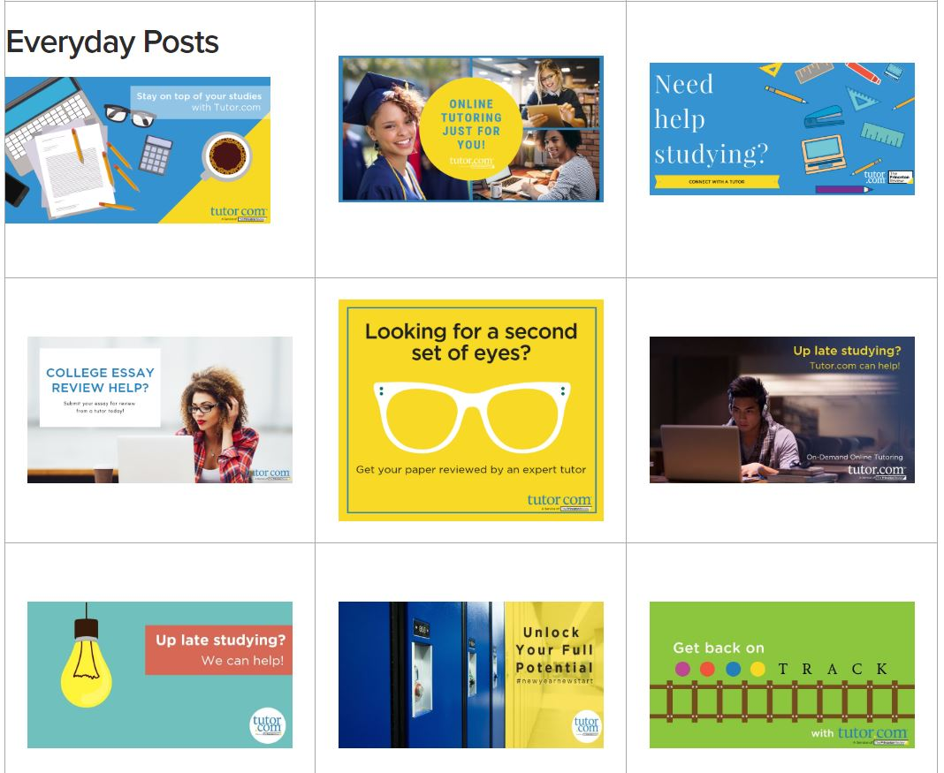

Questions? Comments?
Contact us at clientsupport@tutor.com.

