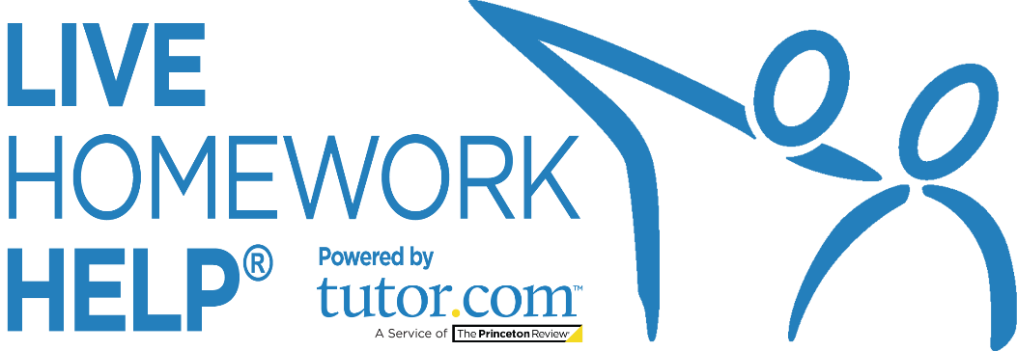
PRESS
GUIDE
Promotional Copy to Help You
Promote the Service in Your Community

Questions? Comments?
clientsupport@tutor.com
2020_LIB_HWAK_Press_Guide

News Articles: Examples & Ideas for Libraries
Social media is a great way to stay connected with current patrons. But how do you reach those who are unaware of the library and its resources? Try your local newspaper!
An engaging article published by your community’s local news source—online and in print—generates interest and increases awareness of your library's great services. Moreover, articles give you the space to get into the nitty gritty of your offerings and they have a wider reach than a flyer or poster does (though we encourage posting those in your library and around town, too!).

Whether you are submitting an article to be published or contacting a reporter to generate a story, utilizing the local press will help to widen your library’s reach in the community. To help you get started and to inspire some ideas, we have provided some suggested topics for articles and examples that other libraries have used in the past. Read on!

Headlines and Topics:
- “Stuck on a problem? Need homework help? Get to your library—online!”
Write about the launch or remind your community about your current Live Homework Help program.

- “Get ready for back-to-school time with free resources from your library”
Submit an article summarizing the back-to-school resources your library provides to families in your community—including access to free expert support from Live Homework Help.

- “Don’t break your back-to-school budget. Use FREE library resources!”
Summarize how accessing free Live Homework Help SkillsCenter™ resources can help refresh students’ minds—totally free of cost.

- “Prepare for the [SAT®/GRE®/etc.] — FREE from your library!”
Just ahead of ahead of testing periods and around midterms and finals, recap the test prep and
study resources you have available for all learners, including FREE expert tutoring, writing help,
SAT®/ACT® Essentials, and graduate program test prep from Live Homework Help and
The Princeton Review.®

- “FREE library resources you can use from home”
Outline the digital resources that patrons can use from the comfort of their home, including access to free expert tutoring and homework support from Live Homework Help.

- “Get help on your college application with FREE library services”
Create an article that lists the different services available for students applying to college.
Whether it's research help or essay writing, Live Homework Help has the help learners need.

- “Looking for FREE career help? Look no further than your library!”
Help recent graduates or those looking for a new career by sharing information about the
career services your library has to offer, including the Live Homework Help Adult Center.

About Live Homework Help® and Tutor.com

Live Homework Help provides live online tutoring and homework help to residents of Alaska through funding from the State of Alaska and a grant from the Alaska State Library to the Alaska Library Network. There is no cost to patrons to use the service.

Live Homework Help is powered by Tutor.com, the world's largest and highest-rated online learning service. Since 2000, the Tutor.com professional community of more than 3,000 highly vetted expert tutors has delivered close to 19 million one-to-one tutoring and professional development sessions in a modern online classroom optimized for learning.

Published Examples
Introducing New Digital Offerings and Resources
https://gwinnettcitizen.com/5017-gwinnett-public-library-introduces-new-digital-offerings- and-resources
The Gwinnett Citizen reviews the newest online services offered by the Gwinnett Public Library system. This article highlights how, through Live Homework Help, the library can offer free academic support to the county's 180,000 students. For greatest impact, share numbers like these that show the potential reach your library has in providing the community with critical academic services.

Camden County Library System Wins State Early Literacy Programming Award
https://southjerseyobserver.com/2020/05/06/camden-county-library-system-wins-state-early-literacy-programming-award-operations-continue/

In the midst of the COVID-19 pandemic, to remain accessible and stay relevant to their patrons, libraries across the country had to reinvent themselves. This shift in thinking brought about great innovations in digital library services, with libraries engaging patrons in the online sphere more than ever. Use this article as template for how to share all your great digital programs and services, including online tutoring services, with your community through the press. (As Camden County Library shows, you can even couch your offerings in a laudatory article about your award-winning programming!)

National Library Week Encourages Residents to Find the Library at Their Place
https://www.sweetwaternow.com/national-library-week-encourages-residents-to-find-the-library-at-their-place/

To celebrate National Library Week, this media outlet featured Sweetwater County Library’s virtual services and resources, including e-books, story times, and online tutoring. When you reach out to your local newspaper, be sure to offer your own insights, just as the Assistant Director of Sweetwater’s library did: “[Our] resources are much more than the items available in the buildings … Visit us online this National Library Week and see all that we have to offer.”

