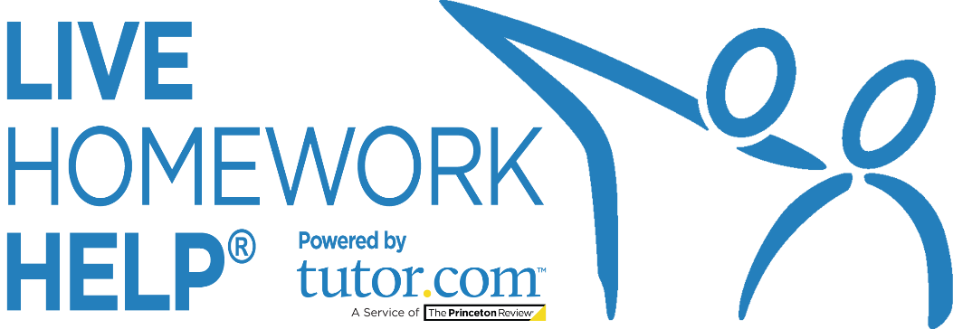
NEWSLETTER
TEMPLATES
Promotional Copy to Help You
Promote the Service to Your Patrons

Questions? Comments?
clientsupport@tutor.com
2020_LIB_HWAK_Newsletter_Templates

Promotional Topics Included in This Packet:

- K-12 Student Newsletter Article
- SAT® / ACT® (College Prep) Newsletter Article
- Adult Learner Newsletter Article
- Career Center Newsletter Article
- Where to Find More Promo Materials

K-12 STUDENT ARTICLE
for LIBRARY NEWSLETTER
Need a hand with homework? We can help!
Did you know? Live Homework Help can help you get your homework done, write your paper, or study for your test so that you can get back to your life. If you’re getting frustrated, this service can help you get unstuck. Create a FREE account by using your library card number at LAM.Alaska.gov/sled/homework and start getting the help you need—online and on-demand. Tutors are available Noon—Midnight, daily.
“Now it doesn’t take me 3 hours to finish my chemistry homework. I love Tutor.com!”
—10th Grade Alaska Student
Students and parents can get help with any kind of academic question in math, science, English, social studies and writing. Expert tutors work with students in kindergarten through 12th grade and can even help with AP®-level and intro-level college coursework.
Connecting with a tutor is easy. You just need your library card and any Internet-connected device. Head to LAM.Alaska.gov/sled/homework. We can help!
Live Homework Help is funded by the State of Alaska and through a grant from the Alaska State Library to the Alaska Library Network. There is no cost to patrons to use the service.

SAT®/ACT® ARTICLE
for LIBRARY NEWSLETTER

Hey High School Juniors and Seniors!
Stressing over the SAT®/ACT®? You already know that your score on these exams is a key component of your college admissions process. But did you know that you can get help with your test prep—totally FREE? Live Homework Help online through your public library is here to help you on your path to college!
Be sure to check out Live Homework Help’s SAT/ACT Essentials. Powered by the world leader in test prep, The Princeton Review®, this online service will give you the edge you need to reach your target score. With it you’ll be able to:
- Complete a full-length practice test and see your score
- See the areas in which you need to improve
- Watch videos to learn important test-taking strategies
- Take practice drills to help raise your scores

We know that preparing for college can be overwhelming. Fortunately, SAT/ACT Essentials is available 24/7—so can easily fit study time into your busy schedule!
Just remember: Getting into your dream school takes more than great test scores. Luckily, Live Homework Help can also help you boost your GPA with its free academic tutoring from expert tutors. Get on-demand homework help, assistance in writing a strong college application essay, and more! Tutors are available online, on demand Noon—Midnight, daily—no appointment necessary. You just need your library card to get started. Visit LAM.Alaska.gov/sled/homework today!
[Insert current year’s SAT/ACT test dates here]
Live Homework Help is funded by the State of Alaska and through a grant from the Alaska State Library to the Alaska Library Network. There is no cost to patrons to use the service.
ADULT-FOCUSED ARTICLE
for LIBRARY NEWSLETTER

Live Homework Help’s Adult Center
Free on-demand, expert tutoring online through the library
Are you returning to school, working towards your GED, or refreshing your skills for work? Get anonymous, private, online tutoring for any kind of academic question in math, science, English, social studies, and writing anywhere you have an internet connection with Live Homework Help—FREE through your library!
Expert tutors are available Noon—Midnight, daily from any Internet-connected device at LAM.Alaska.gov/sled/homework. Enter your library card login to get started. Live Homework Help’s expert tutors can help you with anything from learning how to add fractions to understanding your college-level statistics class.
You can choose to connect with a tutor right away or use one of the other great features of the service, including practice quizzes to help study for an exam, online resources from the SkillsCenter Resource Library, or the Drop-Off Writing Review service, where expert writing tutors review and give you feedback on your writing assignments before you have to turn them in.
If you’d like a demonstration of how to use the service, please visit the library or ask your tutor for a tour of the classroom at the start of your session. Don’t be afraid to get the (free) help you need. Improve the quality of your education—and your life—by logging in today at LAM.Alaska.gov/sled/homework.

Live Homework Help is funded by the State of Alaska and through a grant from the Alaska State Library to the Alaska Library Network. There is no cost to patrons to use the service.
CAREER HELP ARTICLE
for LIBRARY NEWSLETTER
The Job Center @ Live Homework Help
Help for Job Seekers Is Just a Click Away!
Out of work? Looking for a career change? Need to dust off your resume? You don’t have to face it alone. Get anonymous, private, online academic tutoring and career coaching anywhere you have an Internet connection with Live Homework Help’s Adult Center—FREE through the library!
Expert tutors and career coaches are available to you online, Noon—Midnight, daily.
What are my options?
- Career Coaching: Work one-to-one with professional career coaches LIVE in a private, supportive environment for help with online job searches, resume writing, interview preparation, writing a cover letter, help with online applications, and more.
- Drop-Off Resume Reviews: You can also drop off your cover letter or resume any time, 24/7 for an overnight review. Career coaches will write up a summary of feedback and leave comments on your document. You’ll receive the tutor’s review in your own secure online drop box.
- SkillsCenter™ Resource Library: Access helpful resources for your job search, including resume and cover letter templates and samples.
Getting help is easy and it’s free. Simply visit LAM.Alaska.gov/sled/homework from any device with an Internet connection. Need help at a different time? No problem! The Drop-Off Writing Review service & SkillsCenter Resource Library provides 24/7 access to academic resources and thousands of job search resources such as resume templates and interview tips—any time, day or night.
To learn more about the program, visit your library or ask your tutor or career coach for a tour of the online classroom during your first session.
Don’t be afraid to get the (FREE!) help you need. Log in today!
Live Homework Help is funded by the State of Alaska and through a grant from the Alaska State Library to the Alaska Library Network. There is no cost to patrons to use the service.

Looking for More Promotional Materials?

Be sure to check out your Live Homework Help Client Resource Center at tutor.com/clientcarelib/ak for more resources to help build awareness of the program, including digital marketing pieces for use in emails, newsletters, on websites, social media, and more!
