FALL 2020
PROMOTIONAL
CALENDAR
Use the messaging below in student emails, social media posts, or messages on your website. These templates are adjustable to fit your timeline and messaging needs.
Date | Message Content | Optional Graphic (preview)
Late Aug/  Early Sept | It’s Back to School Season!  Did you know? You have free access to Tutor.com through the U.S. Military! Get FREE online tutoring to support your academic success this school year.  Use Tutor.com to:Use Tutor.com to:  - Connect with one of our 3,000+ expert tutors in an online classroom  - Drop off an essay for review and get feedback within 12 hours  - View your transcripts and replays of previous tutoring sessions  - Save and schedule appointments with your favorite tutors!  Tutors are available to help with:  - Algebra  - Calculus  - English  - Writing  - Earth Science  - History  - …and more!  To access free online tutoring, please visit www.tutor.com/military to get started. For more information, check out the Tutor.com How It Works Guide, available in English and Spanish.  Take advantage of this FREE service whenever you need the extra help! If you have any questions, please reach out to militarysupport@tutor.com. Subject list available here.
Early Sept | Kick Off the School Year Right!  Kick off the 2020-2021 school year right with Tutor.com! In an average 30-minute session, you can get the homework help you need from a friendly subject-matter expert—FREE to you through the U.S. Military.  Visit www.tutor.com/military to connect with a tutor today!
Late Sept | Falling Grades?  Jumpstart your studies with help from Tutor.com! Military families have access to FREE on-demand tutoring.  Make this term a great one by connecting with a tutor today. Visit www.tutor.com/military to get started.

Early Oct | Got Writer’s Block?  Get help from an expert writing tutor—FREE through Tutor.com! Connect to a live session for immediate help brainstorming and organizing, or drop off your current writing draft to get back comprehensive feedback in under 12 hours.  Visit www.tutor.com/military to get started today! | 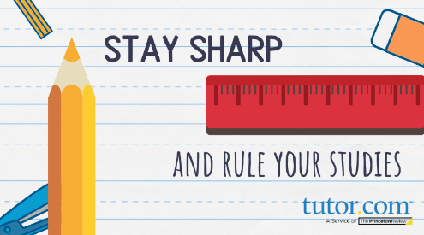
Mid-Oct | Fall into Good Study Habits!  Leaving homework to the last minute? Connect with a tutor for helpful study tips to get better organized, or get help with a specific subject or problem. All military families have FREE, on-demand access to online tutors.  Take advantage of this service by connecting with a tutor today. Visit www.tutor.com/military to get started.
Late Oct | Hocus Pocus – Don’t Lose Focus!  Has homework become frightening? Overcome your fears with FREE practice and expert help from Tutor.com. All military families have access to free, on-demand online tutoring through Tutor.com.  To connect with an online tutor, visit www.tutor.com/military today!
Early Nov | Cramming for Midterms?  Don’t panic! Connect with an expert online tutor FREE to help you prepare.  Military families are eligible for free on-demand tutoring through Tutor.com, so get your questions answered and get in the practice you need with friendly and supportive tutor! All it takes is a few clicks. Get started at www.tutor.com/military today.
Mid-Nov | Need a Study Buddy?  Tutor.com’s expert online tutors are available to you completely FREE through the U.S. Military! Get direct help in a range of topics in math, science, history, writing, and much more!  To connect with a tutor, head to www.tutor.com/military today!
Late Nov | Get Back on Track  Is life derailing your studies lately? Get back on track and pick up speed with Tutor.com’s on-demand online tutoring—FREE for military families! Visit www.tutor.com/military to get started.
Early Dec | Finals Are Coming: ‘Tis the Season to Grind!  Use your free access to on-demand tutoring to give your study routine a helpful boost! Experts are available to help you prep for exams and work with you to practice before your tests!  End the semester strong by connecting with an online tutor. Visit www.tutor.com/military to get started.
Late Dec | Wrap Up the Semester with Tutor.com  Take advantage of the FREE resources the Tutor.com has to offer—including one-to-one tutoring sessions with expert online tutors!  Visit www.tutor.com/military to get started.

Partners & Promoters:
Your Fall 2020 graphics come in two convenient sizes:
- (1080 x 1080) for social media
- (3840 x 2160) to share on big screens (hi res!)
Find these downloadable graphics here in a convenient ZIP format:
Tutor.com/military Partners & Promoters Page.

