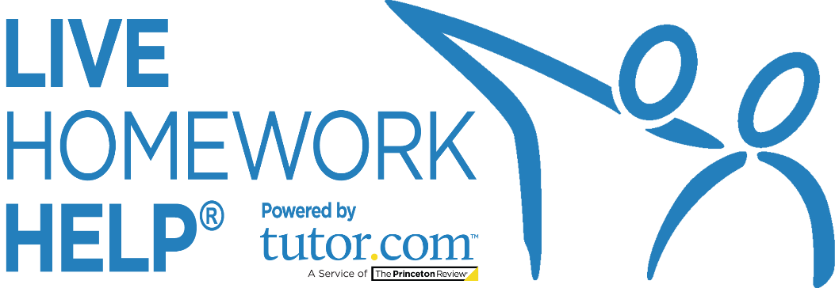
PRESS
RELEASE
Promotional Template to Help You
Promote the Service to Your Patrons

Questions? Comments?
clientsupport@tutor.com
2020_LIB_HWAK_Press_Release
Press Release Template for Live Homework Help®

Live Homework Help® Continues to Help Thousands of Students and Job Seekers
Provided by Alaska Division of Libraries, Archives & Museums and powered by Tutor.com
Month Day, Year - Just in time for back-to-school-season, [Library Name] announces the annual relaunch of Live Homework Help for all students in the state of Alaska. Live Homework Help, one of the most widely used library resources across the state, connects students at their time of need to one of over 3,000 highly vetted expert tutors—online and on demand.
In 2005, the Alaska Division of Libraries, Archives & Museums launched Live Homework Help, powered by Tutor.com, through the Statewide Library Electronic Doorway (SLED). With the goal of helping students across the state receive equal access to critical academic support, the program has since served hundreds of thousands of on-demand tutoring, homework help, and career coaching sessions to Alaska students, parents, adult learners and job seekers.
With instant access to one-to-one homework help and tutoring through Live Homework Help, students can lower their anxiety and raise their confidence about their schoolwork. Ninety-five percent (95%) of survey respondents report that Live Homework Help helped them improve their grades, complete their homework assignments, and raise their confidence.
“I love it! My tutor Nicolas P was very helpful and now I'm sure I will pass
my math test tomorrow. Thank you so much for making this service!”
—11th grade Alaska student
Powered by Tutor.com, the nation’s largest online tutoring service, Live Homework Help connects K-12 and early college students and adult learners to online, on-demand academic tutoring, homework help, and test preparation. Any library patron can connect with a highly qualified, expert tutor in a safe and secure online classroom. Tutors are available in a variety of subjects and test prep areas from Noon—Midnight, daily. Live Homework Help also offers expert writing help, test prep resources from The Princeton Review® for the ACT®/SAT® exams, Advanced Placement (AP®) course videos, and more. Many resources are available 24/7.

“Amy M did a wonderful job explaining division using Common Core Math. Now I feel more
comfortable helping my son with the new way they are teaching!! Thank you!!”
—Parent of a 4th grade Alaska student

All Alaska residents with a library card can access the online service anywhere from any Internet-connected device. Academic tutoring, job search assistance and career coaching is available from Noon—Midnight, daily.
To get started, learners can visit LAM.Alaska.gov/sled/homework.
Academic support for K-12 through college students & adult learners includes:
- Academic Tutoring: Students of all ages can get help with homework, test preparation, skills and concepts from class, and AP test preparation. Subjects include math, science, writing, English, Spanish, social studies, ACT/SAT, practice tests for the GED, HiSET and ASVAB exams as well as for the following graduate school exams: GRE®, GMAT®, LSAT®, and MCAT®. Microsoft® Office tutoring is also available to Live Homework Help users.
- Writing Help: Live Homework Help’s expert writing tutors do more than offer feedback on students’ grammar and mechanics; they help them become better writers. To achieve this, tutors focus on higher-order concerns and offer students comprehensive, constructive feedback. Learners can submit their essays, book reports, and even their college or scholarship application essays for (1) live, on-demand writing help in an interactive, online classroom, or (2), for review through Live Homework Help’s 24/7 Drop-Off Writing Review service. The latter option allows tutors to work asynchronously to provide thorough feedback to students with 12-hour turnaround.

- ACT and SAT Essentials from The Princeton Review: Students preparing for college entrance exams can take practice ACT and SAT tests, receive a full score report that includes suggested areas for review, view video lessons on tested concepts, and use practice drills from The Princeton Revie® to help reach their target scores.
- Graduate School Entrance Exam Practice: Adults preparing to apply to graduate or professional degree programs can use The Princeton Review’s practice tests for GRE, GMAT, LSAT, and MCAT exams to focus their study time on areas in need of improvement.
- Practice Quizzes: Students preparing for an end-of-chapter test, final exam, or standardized test can use Live Homework Help’s Practice Quizzes to assess their knowledge on over 100 areas in math, science, and social studies. Practice quizzes are also available for the ASVAB military entrance exam.
- Study Resources: The SkillsCenter™ Resource Library provides 24/7 access to thousands of educationally sound resources. Students can watch instructional videos, download practice worksheets, customize their own flashcards for studying and get test taking tips and much more. Job seekers have access to résumé templates, job search websites and career advice.
- Videos lessons: Students can access video lessons 24/7 for AP courses as well as subject-area lessons for math and English to review or learn new concepts.

- Job Search Assistance: Adults can work one-to-one with professional job search coaches in a supportive and encouraging environment for help with job searching, online applications, resume writing, interview preparation, and more. This service is easy to use, and career coaches are experienced in working with job seekers of all levels.

For help accessing this free service, patrons can visit your local library and ask for a live demonstration or ask for a virtual tour of the online classroom from a tutor or career coach once they log in to their first online session.

Live Homework Help is funded by the State of Alaska and through a grant from the Alaska State Library to the Alaska Library Network. There is no cost to patrons to use the service.

About [Your Library]
Add information here.
About Tutor.com
Tutor.com, a service of The Princeton Review, helps learners realize and reach their full potential. Our 3,000+ expert, online tutors connect with students at their precise moment of need, so they receive the support they need to feel confident, persist through their educational journey, and achieve success. Tutor.com partners with public libraries, K-12 schools, and colleges and universities, as well as corporations and non-profit organizations around the world to help equalize access to effective educational support. Tutor.com provides learning that students love, partnerships that organizations love, and outcomes that everyone loves. Tutor.com was founded in 1998 and has served close to19 million one-to-one, online tutoring sessions.

