EMAIL
TEMPLATES
Promotional Copy to Help You
Promote the Service to Your Patrons

Questions? Comments?
clientsupport@tutor.com
2020_LIB_HWAK_Email_Templates
Promotional Topics Included in This Packet:

- Email Reminder to Library Staff
- Letter or Email to Schools
- Where to Find More Promo Materials
REMINDER EMAIL TO LIBRARY STAFF

Online Tutoring and Career Help from Live Homework Help®!
Dear Colleagues,
As we begin a new school year [OR INSERT APPROPRIATE SEASON/REASON FOR REMINDER], I wanted to remind you of one of our popular services for students and job seekers: Live Homework Help, powered by Tutor.com! This program offers online academic tutoring and test prep to students at all levels, from K-12 to college and adult, as well as job search assistance.
All sessions are conducted online by highly vetted expert tutors. Patrons can work with an online tutor Noon—Midnight, daily by simply going LAM.Alaska.gov/sled/homework. Additional 24/7 features are available including practice quizzes, Drop-Off Writing Review, SAT/®ACT® Essentials from The Princeton Review®, graduate school practice tests (GRE®, GMAT®, LSAT®, MCAT®), and our SkillsCenter™ Resource Library.

Patrons can connect to Live Homework Help at LAM.Alaska.gov/sled/homework
from any Internet-connected device using their library card number.
Live Homework Help service helps us provide more in-depth academic support and career assistance to students and adults. Please remember to actively promote the service to our patrons so they are aware of the valuable ways our library supports them in their day-to-day lives.
If you would like to learn more, please attend an online training session. To see dates and times for trainings or view and download recorded sessions, visit tutor.com/clientcarelib/ak.

Live Homework Help is funded by the State of Alaska and through a grant from the Alaska State Library to the Alaska Library Network. There is no cost to patrons to use the service.
LETTER OR EMAIL TO SCHOOLS
For administrators, teachers, counselors, or school librarians
Get FREE help for your students with Live Homework Help®, powered by Tutor.com
The Alaska Division of Libraries, Archives & Museums would like to remind you of the invaluable free academic resources we offer to your students free through the Statewide Library Electronic Doorway (SLED). Live Homework Help, powered by Tutor.com is available to help students extend their learning day, improve their grades and test scores, and help students be more prepared for class. This service has been offered through our public libraries since 2005 and is a trusted provider of online homework help and test prep for all students in Alaska. Can you help us spread the word?
Live Homework Help provides real-time, online tutoring to students from K-12 through intro-level college. Students can access the service from any Internet-connected device by using their library card to log in at LAM.Alaska.gov/sled/homework. Tutors are online and ready to help with homework problems, writing assignments, concept reviews, test preparation, and skill building Noon—Midnight, daily.
Live Homework Help helps you help your students by:
- Providing Personalized, On-Demand Student Support
Every Live Homework Help session is one-to-one between tutor and student. There is no appointment needed and they can access the service from home. Your students get help with their own specific questions or assignments right when they need it.
- Extending the Learning Day
When the bell rings at the end of the day, learning doesn’t have to stop. Our tutors are available to help your students when they need homework support after school and on weekends. Tutors are available Noon—Midnight, daily.
- Engaging the Student One-to-One
Live Homework Help powered by Tutor.com is committed to student learning. Their highly vetted expert tutors never provide homework answers to your students, but instead guide them to finding the answers on their own.
- Impacting Student Achievement
95% of students who use Live Homework Help say it helps them complete their homework and improve their grades.
.
- Building Confident Learners
3
4
Students also report that Live Homework Help helps them feel more confident in their schoolwork.
To download materials to share with students, please visit our Resource Center at tutor.com/clientcarelib/ak.
Live Homework Help is funded by the State of Alaska and through a grant from the Alaska State Library to the Alaska Library Network. There is no cost to patrons to use the service.

Looking for More Promotional Materials?

Be sure to check out your Live Homework Help Client Resource Center at tutor.com/clientcarelib/ak for more resources to help build awareness of the program, including digital marketing pieces for use in emails, newsletters, on websites, social media, and more!

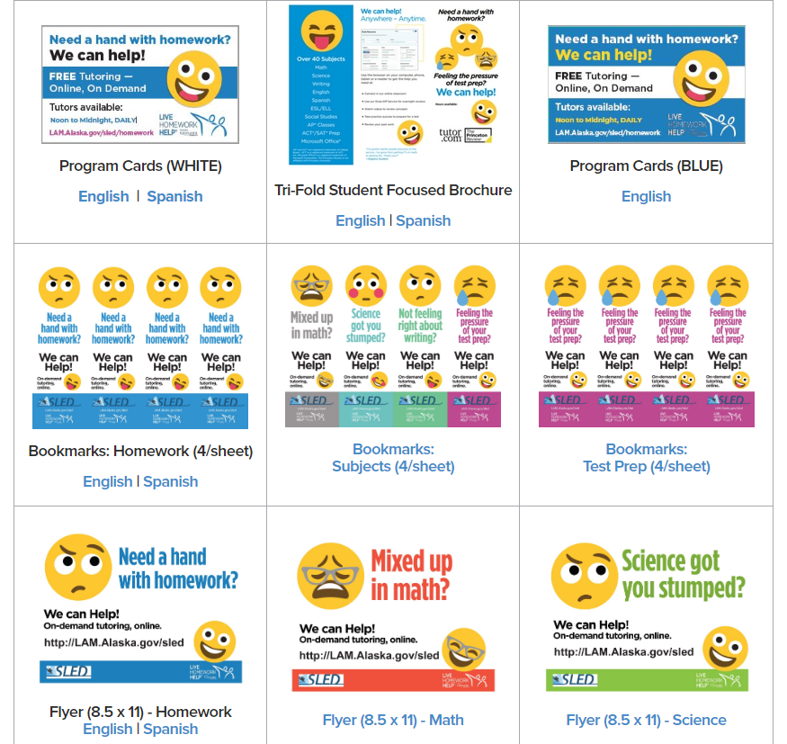

Questions? Comments?
clientsupport@tutor.com

